# **NetSim Mobility File Generation**

**Software:** NetSim Academic/Standard/Pro, Python 3.11

**Project Download Link**:

## **Introduction**

Mobility python script allows user to automatically generate the mobility.csv file without the need for manually writing from GUI. Mobility python script meets the user requirements which involves changing the value of time and distance co-ordinates.

## **Variables used in the python script for generating mobility input to NetSim.**

1. **mobility_type** – This is used to get either linear or circular form of mobility file.
2. **n** - Total number of devices in which file-based mobility is enabled.
3. **deviceid** – list of device id’s that user wants to add into the mobility file separated by comma(**,**).
4. **velocity** - Velocity at which device will move from one point to another.
5. **x_coordinates** –Initial position of the device.
6. **y_coordinates** –Initial position of the device.
7. **distanceStep** – It is used in finding the next location for each device.
8. **timePerStep** – Time gap between two locations.
9. **timeStep** – It is used along with timePerStep to get the time value for node to move.
10. **lengthOfSteps** - Range in which, time value will add into mobility file.

## **How to generate Mobility.csv file**

**Case 1:** Mobility file for uniform straight-line motion

1. Open the Mobility-File-Generator.py script in python IDE.
2. Users can modify parameters like mobility_type, n, distanceStep, timePerStep, timeStep, velocity and x, y coordinates.

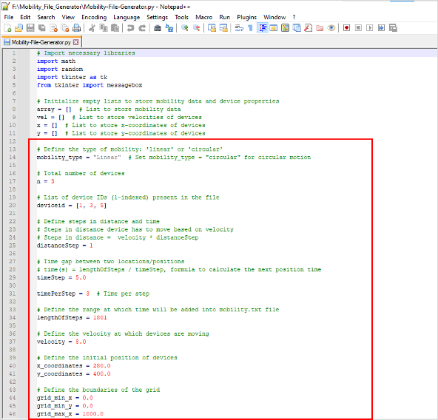

**Figure 1:** User Modify the parameters like velocity and x, y coordinates in Mobility-File-Generator.py.

1. Generating Mobility file is started by opening command prompt in the directory of the Mobility script project and starting the python script as shown below.

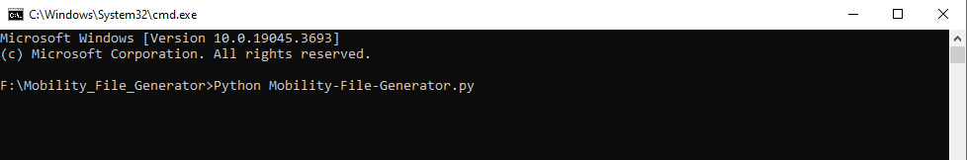

**Figure 2**: Generating Mobility file using command prompt.

1. After executing the command mobility.csv file will be created in the same folder that contains the Mobility-File-Generator.py python script.
2. A sample uniform straight line mobility file generated using this script is shown below.

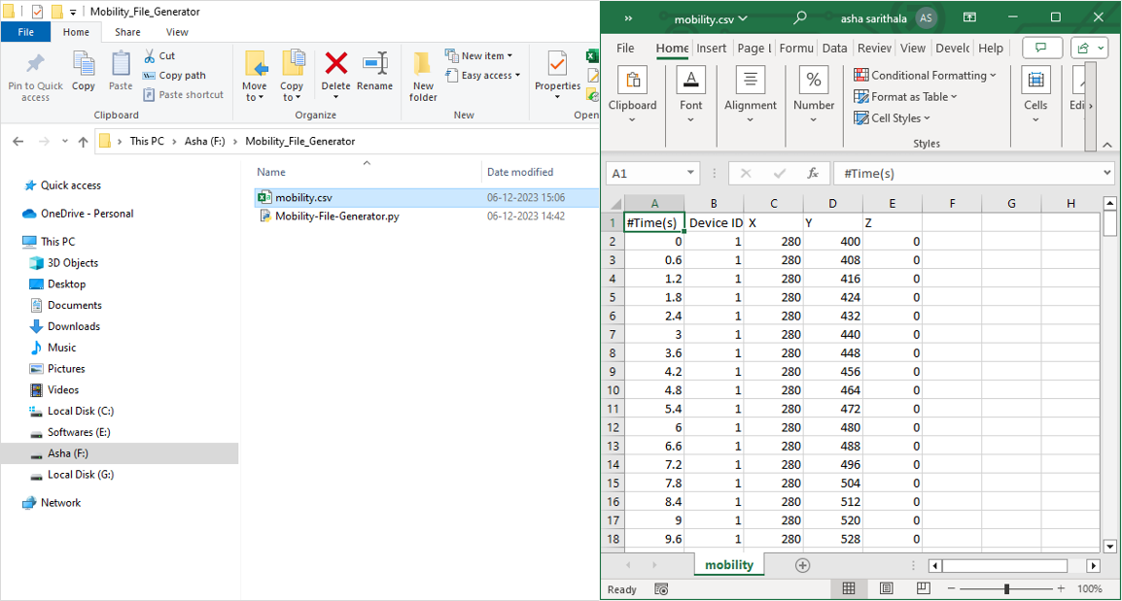

**Figure 3:** Mobility file generated using the script.

**Case 2:** Mobility file for uniform circular motion

1. Users need to set mobility_type = “Circular” and other steps are similar as shown below.

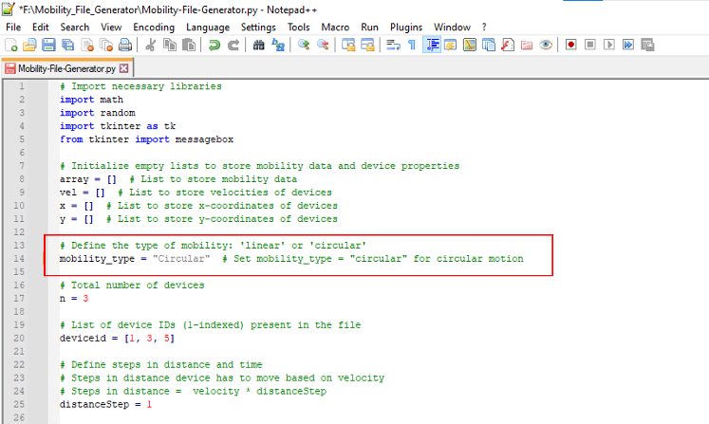

**Figure 4:** Modify the Mobility Type to Circular.

1. A sample uniform circular mobility file generated using this script is shown below.

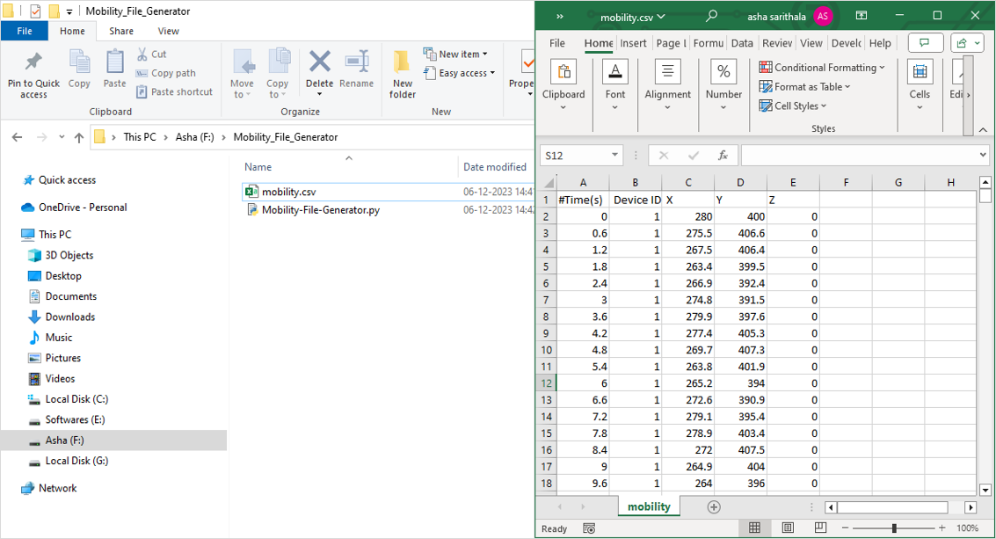

**Figure 5:** Circular mobility file generated using the script.

The script can be modified to generate mobility patterns in addition to those that are supported currently this script supports Linear and Circular mobility types.